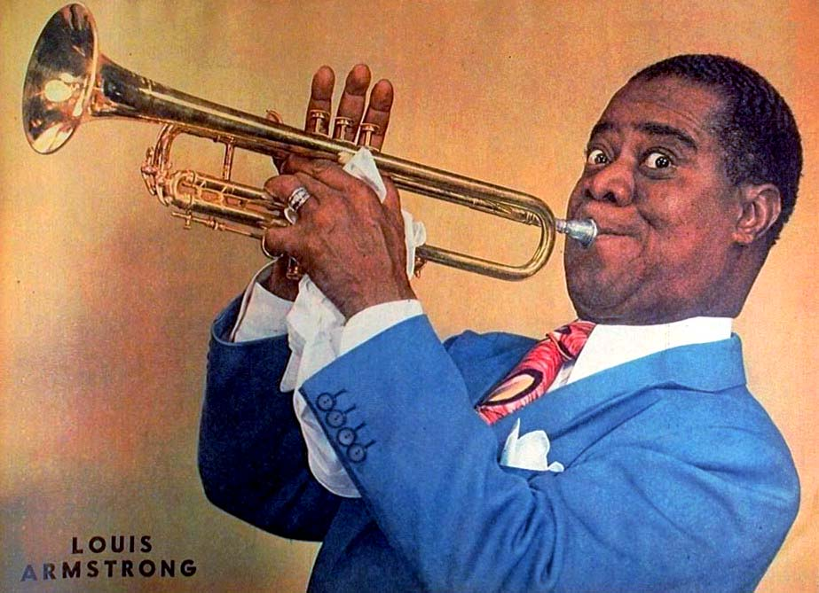
Mixed Nuts


Tonight at 6:30 p.m. March 13, 2025
Get ready for a journey through the golden era with our set of big band hits from yesteryear featuring Louis Armstrong.

Mixed Nuts

Tonight at 6:30 p.m. March 13, 2025
Get ready for a journey through the golden era with our set of big band hits from yesteryear featuring Louis Armstrong.

